21st November 2019

Dear Parent/Carers – Year 4

Bushcraft
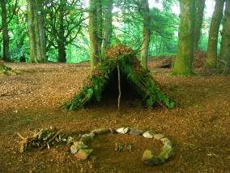
The two day, one night, trip will take place on 6th and 7th May 2020 (Wednesday and Thursday).

The cost of the trip is £116 and we will require a deposit of £36.00 payable by Friday 20th December latest to secure your child’s place. This will be followed by 4 monthly instalments of £20.00. Once your child’s deposit is received you will receive your instalment paperwork which you can pay directly to the office or via SCOPAY.

Please fill in the permission slip below with your deposit of £36 and send into the office by Friday 20th December latest.

Year 4 Team

 CHILDS NAME ……………………………………CLASS……….

BUSHCRAFT YEAR 4 May 2020

Yes, I would like my child to attend the Bushcraft two day trip in May and enclose £36.00 (non-refundable) deposit. Cheques made payable to Heathfield Junior School.

Signed …………………………………………………………parent/guardian

