19th November 2018

Dear Parent/Guardian
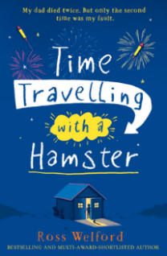

YEAR 5 BOOK CLUB

The Year 5 Book club will be re-starting in January and will be run by Ms Rowlands.

The children have already chosen a book they would like to read called “Time Travelling with a Hamster” by Ross Welford.

The book club takes place once a week at lunchtime in the school library. It is a very popular club and is a good way to encourage reading and expose the children to different texts and discussions on the storyline.

If your child would like to take part you would be required to provide the book. Amazon and Waterstones are good suppliers.

Please fill in the slip below if your child would be interested in joining our year 5 Book club.

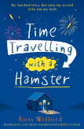
YEAR 5 BOOK CLUB

Child’s Name …………………………………………………………………………….Class ……………………………….

Yes, my child would like to join the Year 5 Book club and I will arrange to purchase a copy of Time Travelling with a Hamster.

Signed………………………………………………………………………….parent/guardian



