January 2019

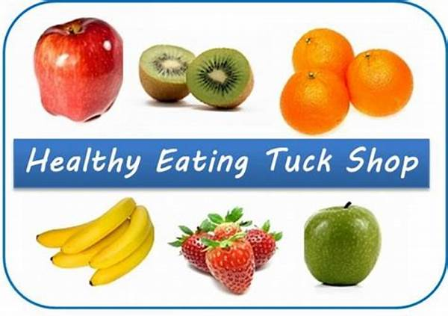

KS2 Healthy Fruit Tuck Shop

Dear Parents and Carers,

Pupil Voice have requested that we set up a Healthy Fruit Tuck shop for KS2 children so that they can enjoy a healthy snack at break time, just like the KS1 children do.

The KS1 Free Fruit Scheme is a government initiative to encourage young children to make healthy choices. We feel that it is important that we enable our older children to continue making these healthy choices and in light of this request propose that we help the pupil voice to run a trial KS2 Fruit Tuck shop with year 6. The outcomes from this trial will decide whether it is something that we can continue throughout the year.

The pupil voice members have looked at the cost of the fruit and have decided that they will need to charge a trial cost of 50p per fruit. This will ensure that we can cover the initial purchase costs and any profits will go towards more stock, playground equipment and edible plants for around the school.

If you would like your child to enjoy a piece of fruit at break time from the ‘Fruit Tuck shop’ please send your child to school with 50p and sign the slip below. The Fruit Tuck Shop will be open on Tuesday 29th January 2019 for our first customers.

Your child will receive a token to take to the Fruit Tuck shop in exchange for 1 piece of fruit. Money must be in by Friday 25th January.

We look forward to welcoming our first customers!

Thank you for your support,

Mrs Sear, Mrs Proctor Lane, Miss Langer and Pupil Voice Team

Fruit Tuck Shop trial

Name of Child:……………………………………………………………………………………..

Class ………………………………………………………………………………………………..




