June 2018

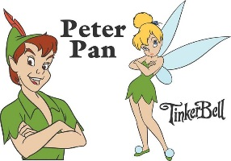
Dear Parents

Peter Pan

We have secured a limited amount of tickets for the pantomime at Richmond Theatre this year on Friday 14th December.

The panto is Peter Pan and Richmond theatre pantos are always amazing and an experience not to be missed.

If you would like your child to attend the cost is £11 and as there will be high demand, names will be drawn from a hat if oversubscribed. Forms must be received by Friday 15th June latest.

Thank you.

Diane Mullen

Child’s Name ………………………………….Class ……………..
Panto Tickets

□ I agree to my child travelling by train to Richmond on 14th December.

□ I enclose £11 (cheques made payable to Heathfield Junior School)

Signed ……………………………………………. Parent/Guardian

