Rotary Club
Young Writer and Young Photographer Competitions 2017

The theme is ‘Reflection’

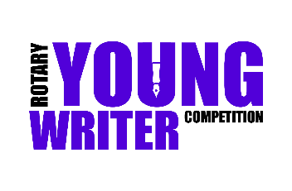
Writing Competition:

Your task is to produce a written or typed story entitled
‘Reflection’.

Your piece could be fiction or non-fiction, a
story or a poem, as long as the piece relates to the theme.

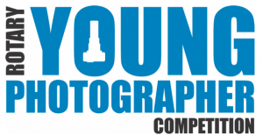
Photography Competition:

Your task is to produce a portfolio of three photographs
based upon the theme, ‘Reflection’ in colour or black and
white on photographic paper. Prints to be submitted
separately. Each print, including any mount should be no larger than A4 size. Mobile phones may be used.

In addition, each entrant should provide a brief sentence of what each photograph represents in relation to the theme.

District competition winners will be asked for a digital copy in jpg format and ideally 5MB for an A4 sized print, on disc (CD-R) as part of the National final submission. Please ensure every photograph, disc or memory stick submitted is clearly labelled with the name of the entrant.

Closing date for both competitions is Thursday 23rd February 2017. Please send any entries to Mrs Pankhurst.

